Sequence Diagram: Event Announcements
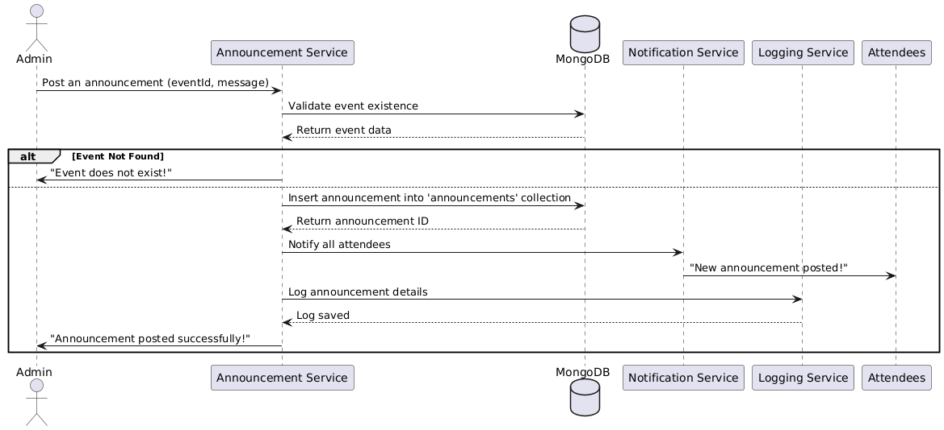

Database
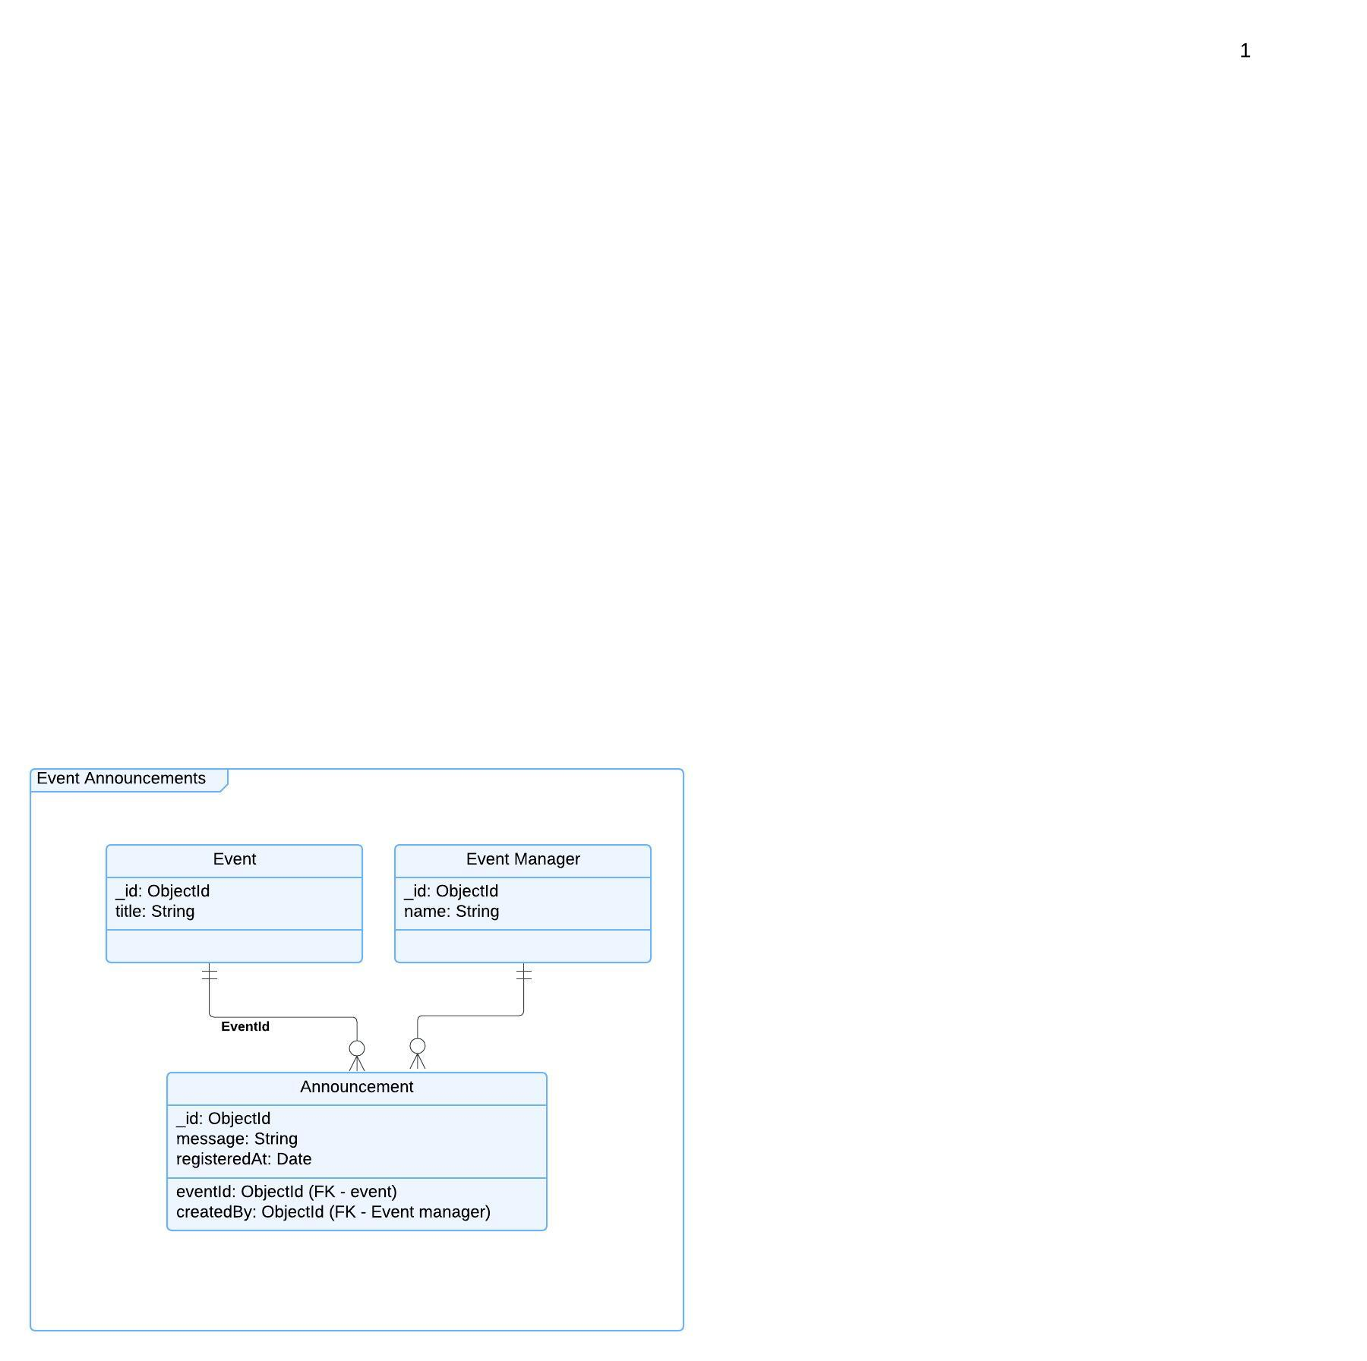

Functional Requirements (FRs)
- FR1: The system shall allow group admins to post announcements for events.
- FR2: Announcements shall be visible to all registered attendees of the event.
- FR3: The system shall send notifications to attendees upon announcement creation.
- FR4: The system shall allow users to view past announcements related to an event.
Non-Functional Requirements (NFRs)
- NFR1: Announcements should be delivered within 5 seconds after posting.
- NFR2: The system shall store announcements for a minimum of one year for reference.

